Q.1   
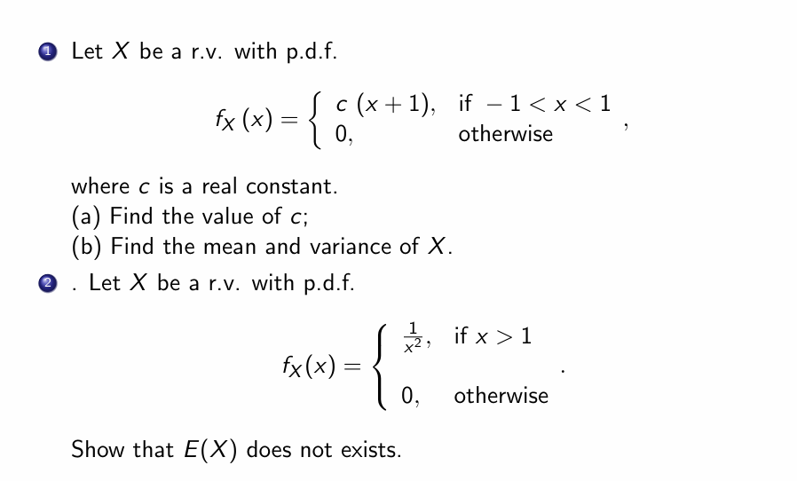

Q.2

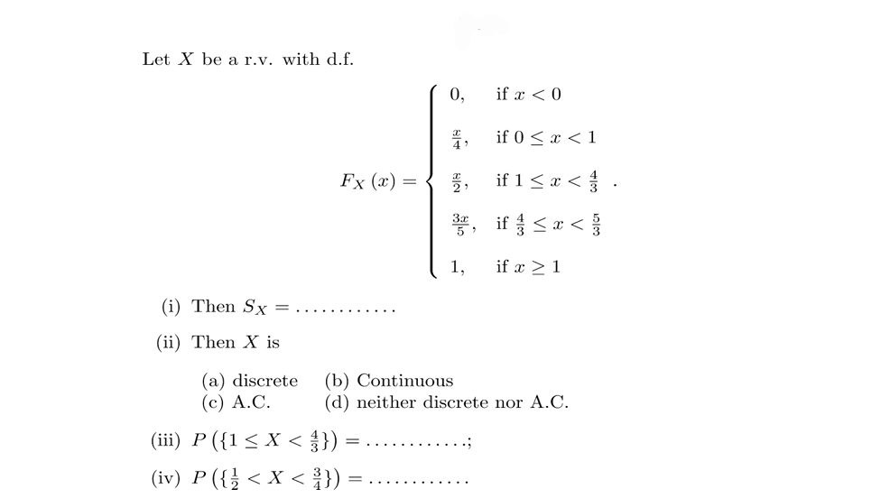

Q.3

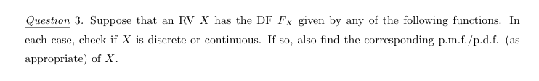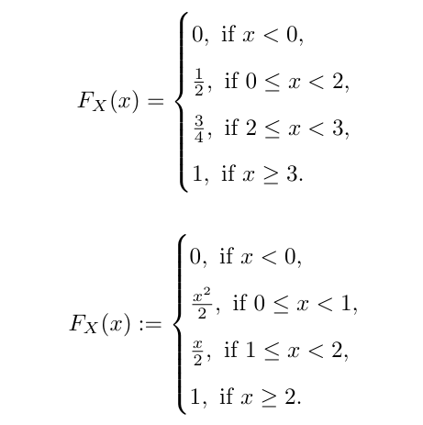

Q.4

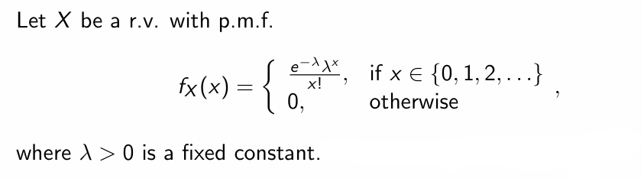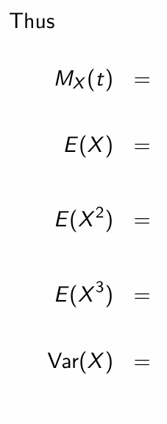

Q.5 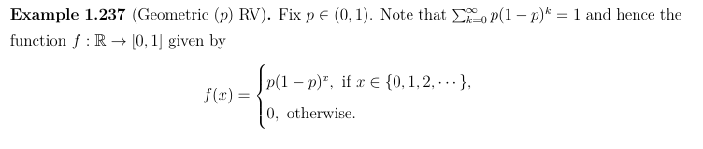

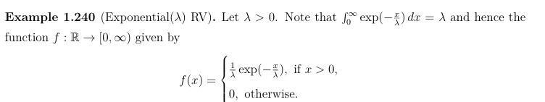

These 2 are standard Random Variable distributions. There are many others like them. Explore them out.

For these 2, calculate expectation values, mean, variance, moment generating function.

Also try to find out where you can find such distribution in application (Bonus Question)

Submission Link : <https://docs.google.com/forms/d/1Y3wAAEveNKBsqnPM3Av4W578LfINIFCB0EszlKrWOIA/edit>